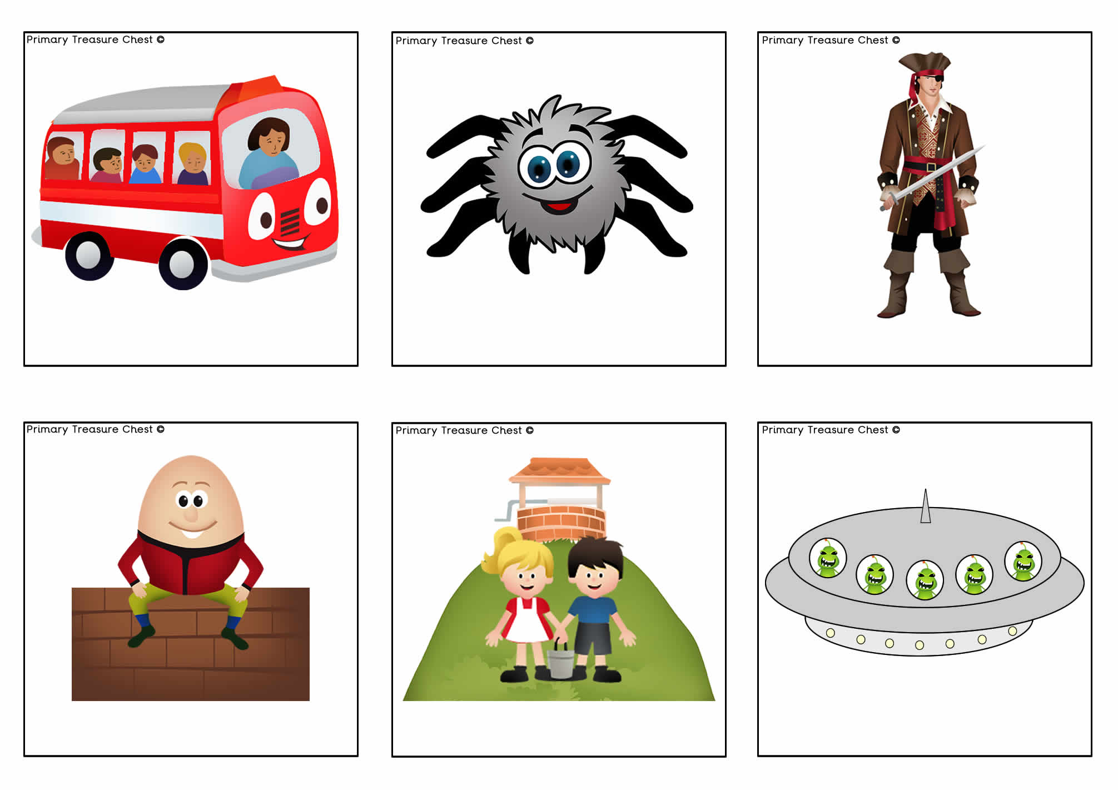

**I’m a Pirate**

**Incy Wincy Spider**

**The Wheels on the Bus**

**Five Little Men ina Flying Saucer**

**Jack and Jill**

**Humpty Dumpty**

**Five Little Ducks**

**Little Bo Peep**

**Baa Baa Black Sheep**

**Hickory Dickory Dock**

**Horsey Horsey**

**Little Peter Rabbit**

**The Grand OldDuke of York**

**1,2,3,4,5 Once ICaught a Fish Alive**

**Ring-a-ring o’ Roses**

**Old MacDonald had a Farm**

**Wind the Bobbin Up**

**Five Currant Buns**

**This Little PiggyWent to Market**

**Five Fat Sausages**

**Five Little Monkeys**

**The Bear Went Overthe Mountain**

**Goosey Goosey Gander**

**Five Speckled Frogs**

**One, Two, BuckleMy Shoe**

**The Gingerbread Man**

**Ten Green Bottles**

**Row, Row, Row Your Boat**

**I’m a Little Teapot**

**Little Miss Muffet**

**One Elephant Went Out to Play**

**Old Mother Hubbard**

**Rain, Rain, Go Away**

**Pat-a-Cake**

**Twinkle, Twinkle, Little Star**

**Pussy Cat, Pussy Cat**